|  |  |  |  |  |
| --- | --- | --- | --- | --- |
| EASY GRADE | | | | |
|  |  | | |  |
| COMPLETION PROGRESS | | | | |
|  | | Manual |  | |

TABLE OF CONTENTS

Marking standards 3

How to access 4

How to grade 5

Exception handling 6

# marking standards

Remember below color guide while marking

* Dark Green Box:Activity Completion / Compliance.
* Light Green Box: Activity submitted for marking.
* Dark Blue: Activity not completed, not started, not attempted
* Red: Activity not completed/ not compliance

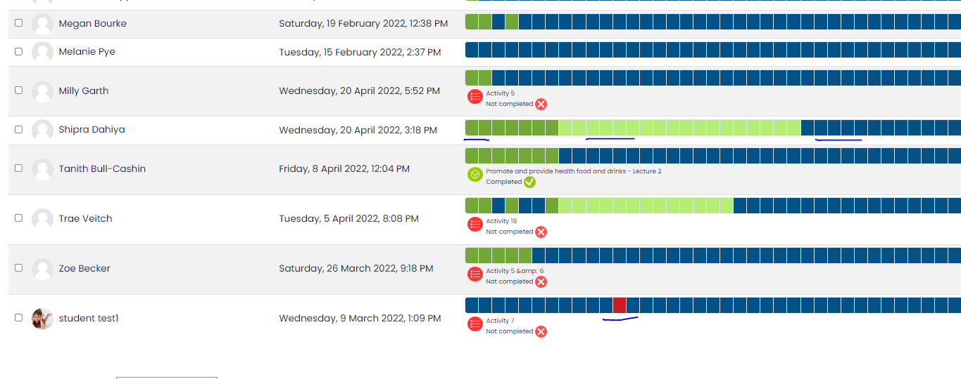

Note: GRADE could be 0(Zero) OR 1(One)

# how to access

Easy Grading development for completion progress

* Admin can check all students progress from right hand slider.
* Trainer can check their course all students progress from right hand slider.
* Student can check their course progress from right hand slider.

STEP 1 (SLIDER - RIGHT HAND SIDE IN CLUSTER):

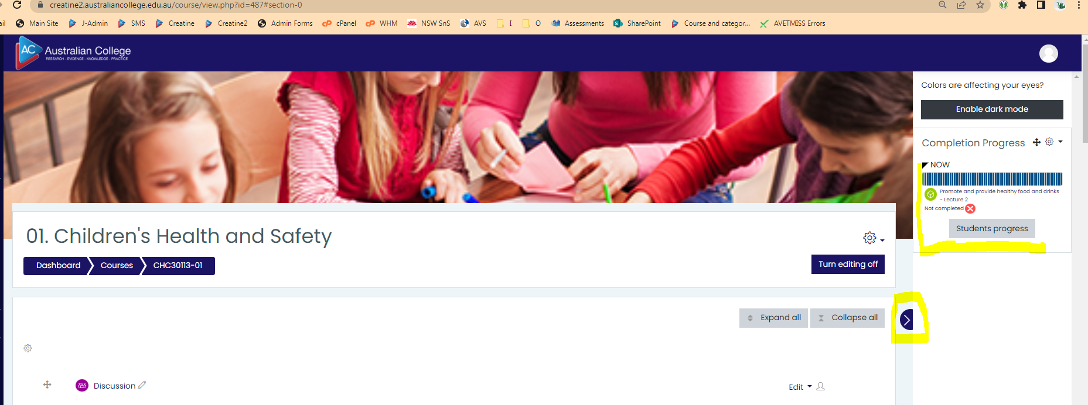

STEP 2 (ADMIN & TRAINNER VIEW):

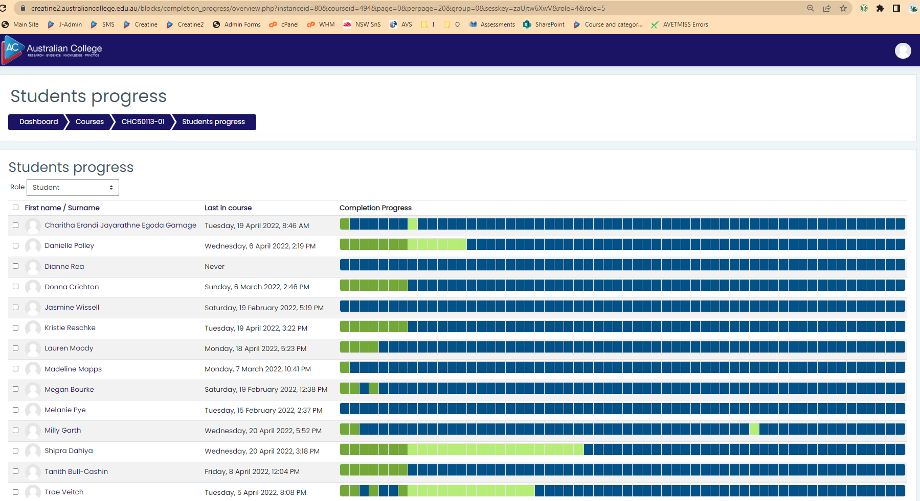

# how to grade

Highlight any activity to view activity name and status.

1. Click color bar to view activity in the same tab for grading.
2. Click on below activity name to view activity in new tab for grading. Recommended

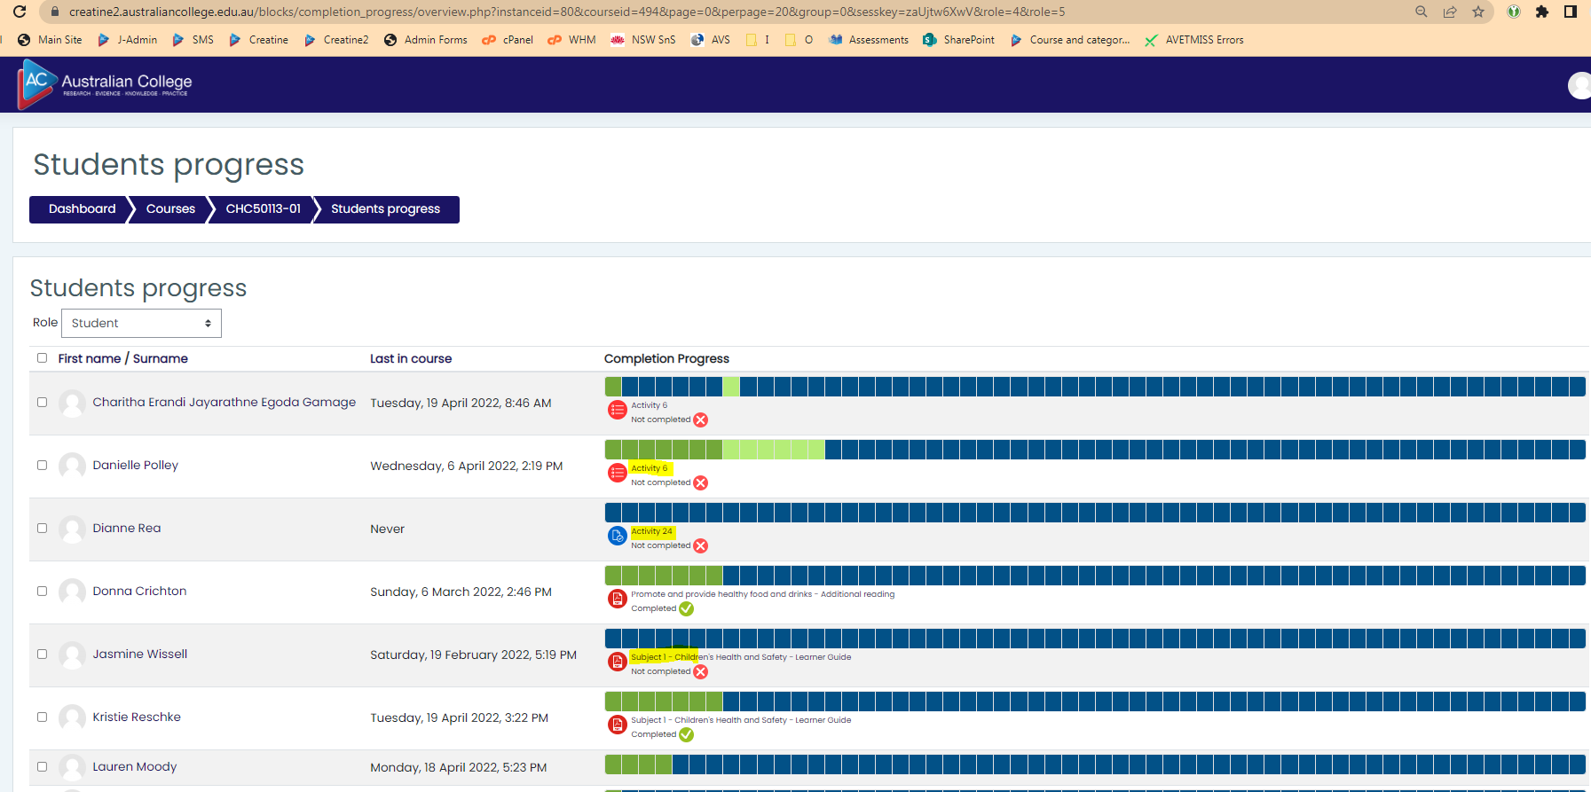

# Exception handling

Pages should ignore.

* Dark Blue: Activity not completed, not started, not attempted

1. Admin can view all student quiz/assignment submissions.
2. Trainer can view all student quiz/assignment submission.
3. Student can view a page to attempt quiz/assignment.

Ignore below pages while grading.

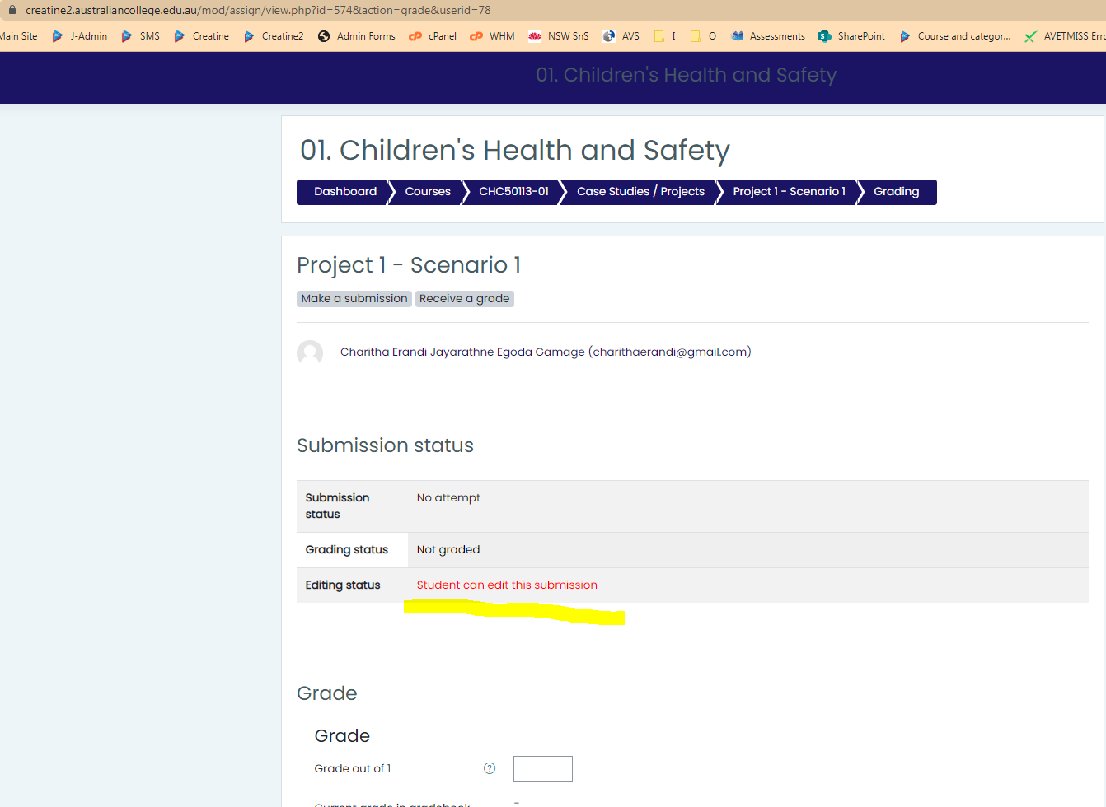

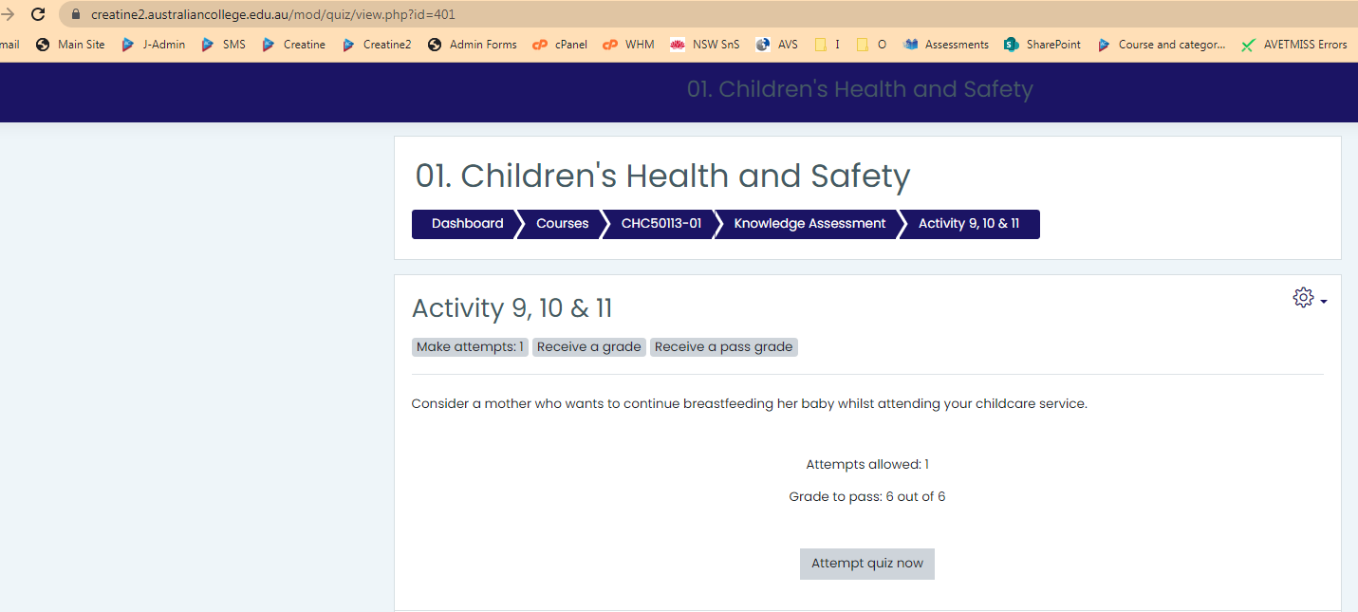

If you have any questions contact IT department: [Syed@australiancollege.edu.au](mailto:Syed@australiancollege.edu.au)